

Arandia College School System

Project Documentation Submitted to the Faculty of Computer Science and Information Technology of Asia Pacific College



April 17, 2015

iAN JASPER gUSI

sHEANNEL bUENAVENTURA

aNDRE pOv fELIX

In partial fulfillment of the Requirements for the subject Applied Projects 2 or Software Development

Contents

I. Narrative 2

A. Executive Summary 2

B. Introduction 3

1. Client Profile 3

2. Project Organization 4

3. Client’s Mission and Objectives 4

4. Project Objectives 4

5. Purpose of the Project 5

6. Rationale of the Project 5

C. System Features and Functions 7

1. Software Environment 7

2. Hardware Environment 7

3. Networking and Security 7

4. Application System Modules 7

II. System Diagrams and Screenshots 8

A. Data Flow Diagram 8

B. Context Flow Diagram 9

C. UML Diagrams 10

Class Diagram 10

Component Diagram 10

Deployment Diagram 11

Object Diagram 11

Package Diagram 12

Composite Structure Diagram 12

Use Case Diagram 13

Activity Diagram 16

State Machine Diagram 18

Sequence Diagram 18

Communication Diagram 18

Interaction Overview Diagram 18

Timing Diagram 18

D. Entity Relationship Diagram 19

E. Data Dictionary 20

F. Screen Shots 21

Lesson Learned 26

# Narrative

## Executive Summary

This Document was created to let the user know more about the system. The project was created for our current client which is Arandia College. Arandia College was a small college before but grew to have many departments. They have now college departments that is being helping unfortunate students have a diplomas. Also Arandia College is a non-sectarian private school.

The Project team are comprised of 3 student from Asia Pacific College. This three were tasked to do system for Arandia College after seeing how the existing school system was. They have found some problems that needs attention. Under the advisory of Ms. Donna Lalusin, this three people continued on developing the system. So far they are close to finishing it.

The Project team’s objective in creating this project was generally spin around the issue of viability and productivity. They made the framework to determine the issue our customer is confronting. This study is constrained to what they can create and come up for them. It concentrates on how they can help them improve their school much. The system features a function that helps the client organize its files and record. It features a Printing feature mostly in the viewing pages, this feature was specially requested by the client. It also has a feature that lets the staff member access and input data in a database system.

While gathering some data, The project team asked the School on how everything was being managed, on what their current business flow begins with folks asking about the accessibility of enrolment the school will react with points of interest upon enlistment and enrolment, then after the subtle elements given by the school the folks will pay the comparing educational cost expense and the school will issue an authority receipt. The guardian will check the approval of the enrolment then the school issues another understudy evaluation. What takes after next is about the folks and the schools cooperation as to understudy records and liabilities. The principal methodology obliges giving evaluation data to folks or watchmen of the understudy. The evaluations that are given to the folks or watchmen are report papers, in those are evaluations of the understudy on each one subject every quarter. Different occasions incorporate about folks paying educational cost and after that they get an authority receipt, if there's else other possibilities in the wake of paying educational cost charge, the guardian could get some information about remaining parities or different installments needed by the school and if there's any, the folks would then be directed to the bookkeeping and check for the understudy's appraisal. Certain occasions might likewise incorporate a guardian educator counsel and if the folks are ready to go and see their youngsters' class standing and an overhaul of their status with respect to conduct and their status inside school, the folks will go and check the records from the counselor and the consultant would then be asked for to present that particular understudy's record subtle elements. For the following set of occasions that we figured out amid customer talks with that we booked, the accompanying would incorporate understudy cooperation’s with school work force about school concerns and/or an overhaul of their status on evaluating and educational cost charges. On the off chance that the understudy needs to know his/her class standing due to concerns on conceivable honor understudies, they must go to their subject instructors and ask about their probability of turning into an honor understudy with the given points of interest exhibited by educators. Next is if understudies needed to know their evaluations, they ought to ask their subject educators consent to view their records from where it began. An alternate plausibility is the understudies are checking their educational cost adjust all alone on the grounds that folks couldn't make it. The understudies ought to go to the schools bookkeeping segment with the end goal them should see their bookkeeping record. Each quarter when the understudies have seen all their quarterly evaluations, a few understudies might want to have a counsel with an educator and all things considered, the understudy would undoubtedly need to request a timetable among the instructor or instructors in regards to meetings on the evaluations and grade calculations. In conclusion they have let us know that everything that needs to do with records was handle by the manager like encoding of the evaluation in the database. Another was observing the evaluations of the understudy to which should be carried out by the guide.

Lastly the project runs on a Java programming language and HTML and in the local servers of XAMPP. The project is windows based operating system. The project is only exclusive to the school, it cannot be access outside of the school premises.

## Introduction

### Client Profile

Arandia College was built as small school for elementary children until they expand and expand and now it has college department. Arandia was the family name of the owner, Mrs. Yolanda Arandia.

It is a non-sectarian private school in Paranaque. The school has only a few students and also few staff.

The school has its own database system and an administrator manages it. As we keep coming to them, we have notice some problems in their systems so that's why we have proposed to create a new system for. The project provides information privacy for the users. A login page is always prompt before anyone can access the main pages.

### Project Organization

#### Project Team :

Ian Jasper Gusi – Project Manager

Sheannel Buenaventura – Programmer

Andrepov Felix – Member

#### Project Professor:

Sir Manuel Sanchez

#### Project Adviser(s):

Mr. Boogie Boydon

### Client’s Mission and Objectives

##### Vision

The Arandia College Inc., a private non-stock, nonprofit, and non- sectarian institution of learning envisions the full development of the learner through proper instruction and training with complete physical facilities to produce individuals who are God-fearing, values-oriented, morally upright and nationalistic capable of competing in the global revolution of knowledge which contributes largely in the progress of the community, society and country.

##### Mission

In pursuit of Vision, Arandia College Inc. commits to:

1. Provide affordable quality education through effective instruction by competent teachers under the leadership of caring school officials.
2. Inculcate love of God, Country, Humanity and Nature.
3. Promote culture of competitiveness in all sectors of the academic community.
4. Develop young citizens' rights, duties and responsibilities for active participation in the progressive and productive home and community life.
5. Keep the learner abreast of technological, vocational and global trends and issues.
6. Enrich teachers; competencies in bringing out their best as educators.
7. Commit the school as leading institution in the society.

### Project Objectives

Our system shall resolve all the inconsistencies and redundancies that a school may encounter. It will be of help to the school with regards to organizing their data. To resolve issues and problems in handling database management. To provide a timely and effective data management system to clients. Offer cost efficient solutions for database management.

### Purpose of the Project

Our venture generally spins around the issue of viability and productivity. We made the framework to determine the issue our customer is confronting. This study is constrained to what we can create and come up for them. It concentrates on how we can help them improve their school much.

### Rationale of the Project

#### The Current Flow

The components of this study were accomplished through research and personal interview of the given client which is, Arandia College. By interviewing the said client, we found out that their current system functions with a database and were filled with uncertain redundant details regarding school data and records. The current system they have because of those problems were deemed useless and they relied only with use of manual input and output, with those problems stated we thought of asking how the progress goes down among people inquiring and enrolling in the school. The process starts with parents inquiring about the availability of enrolment the school will respond with details upon registration and enrolment, then after the details given by the school the parents will pay the corresponding tuition fee and the school will issue an official receipt. The parent will check the validation of the enrolment then the school issues a new student assessment. What follows next is about the parents and the schools interaction with regards to student records and liabilities. The first process goes along with giving grade information to parents or guardians of the student. The grades that are given to the parents or guardians are report papers, in those are grades of the student on each subject per quarter. Other events include about parents paying tuition and then they receive an official receipt, if there’s anything else after paying tuition fee, the parent could ask about remaining balances or other payments required by the school and if there’s any, the parents would then be led to the accounting and check for the student’s assessment. Certain events may also include a parent teacher consultation and if the parents are willing to go and see their children’s class standing and an update of their status regarding behaviour and their status inside school, the parents will go and check the records from the adviser and the adviser would then be requested to present that specific student’s record details. For the next set of events that we found out during client interviews that we scheduled, the following would include student interactions with school personnel about school concerns and/or an update of their status on grading and tuition fees. If the student wants to know his/her class standing because of concerns on possible honour students, they must go to their subject teachers and inquire about their possibility of becoming an honour student with the given details presented by teachers. Next is if students wanted to know their grades, they should ask their subject teachers permission to view their records from where it started. Another possibility is the students are checking their tuition balance on their own because parents could not make it. The students should go to the schools accounting section in order for them to see their accounting record. Every quarter when the students have seen all their quarterly grades, some students would like to have a consultation with a teacher and with that said, the student would most likely have to ask for a schedule among the teacher or teachers regarding consultations on the grades and grade computations. Lastly they have told us that everything that has to do with records was handle by the administrator like encoding of the grade in the database. Another one was monitoring the grades of the student to which is supposed to be done by the adviser.

#### User Information Needs

* Raw Documents
* The users must be knowledgeable in using and how to deal with the system
* The greater part of the System Clients are dependable in every activities that will be carried out in utilizing the System.
* Each client must have just 1 account which is made in a remarkable multi-level client sort like Student, Teacher etc.

#### How the Information is being processed

* For now, everything is being processed manually, though the school have an existing database, it really doesn't help them.

## System Features and Functions

### Software Environment

#### Programming Languages

* Java
* HTML
* Mysql

#### Specific Software

* Eclipse Juno

#### Web Server Application

* XAMPP

#### Operating System

* Windows

#### Other Software

* Notepad++
* Paint

### Hardware Environment

* 2 GHz processor  
  RAM: At least 1 GB RAM  
  OS:Windows XP SP2, Windows Vista SP1, or Windows 7  
  Free Disk Space:4 GB

### Networking and Security

#### Security

* Login pages; Upon accessing the system, the user will be prompt to log in the system before they have access upon any other function or feature that the system is capable of.

#### Server

* Local Server Xampp will be use.

### Application System Modules

* Viewing of grades
* Updating and editing of grades
* Recording of Student's Informations
* Enrolment Queries
* Printing of School documents
* View of Student's class standing
* Updating/editing of Student's Class Standing
* Adding of subjects
* Adding of grades
* Adding of employee
* Updating profile
* Viewing of employee table

# System Diagrams and Screenshots

## Data Flow Diagram

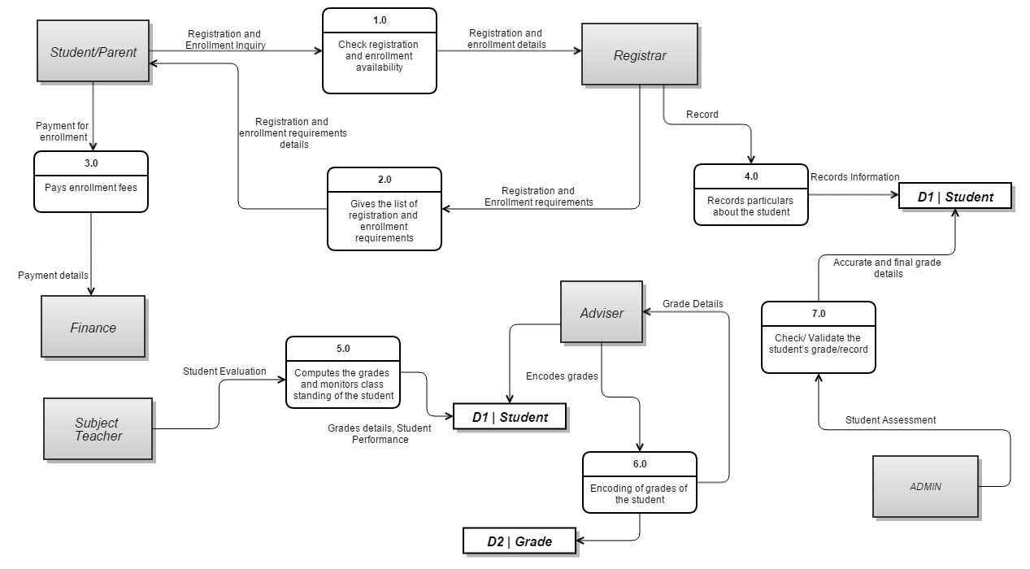

## Context Flow Diagram

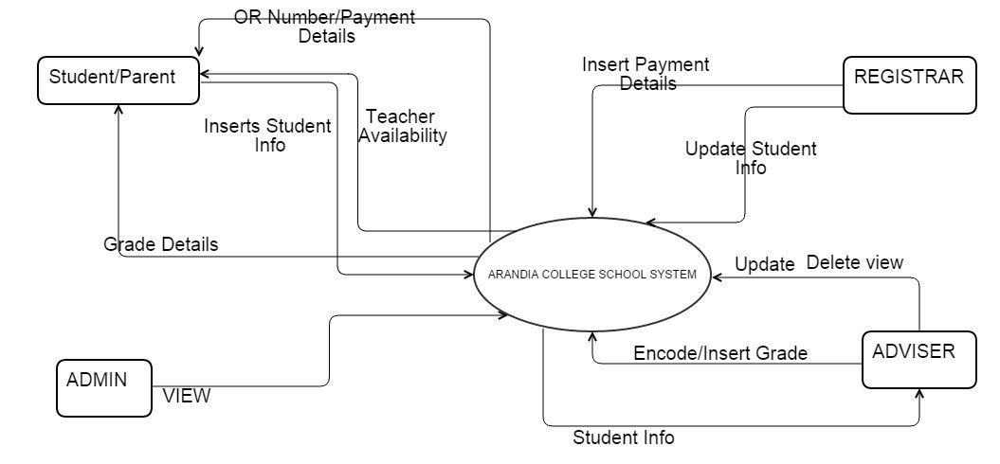

## UML Diagrams

### [Class Diagram](http://creately.com/blog/diagrams/uml-diagram-types-examples/#ClassDiagram)

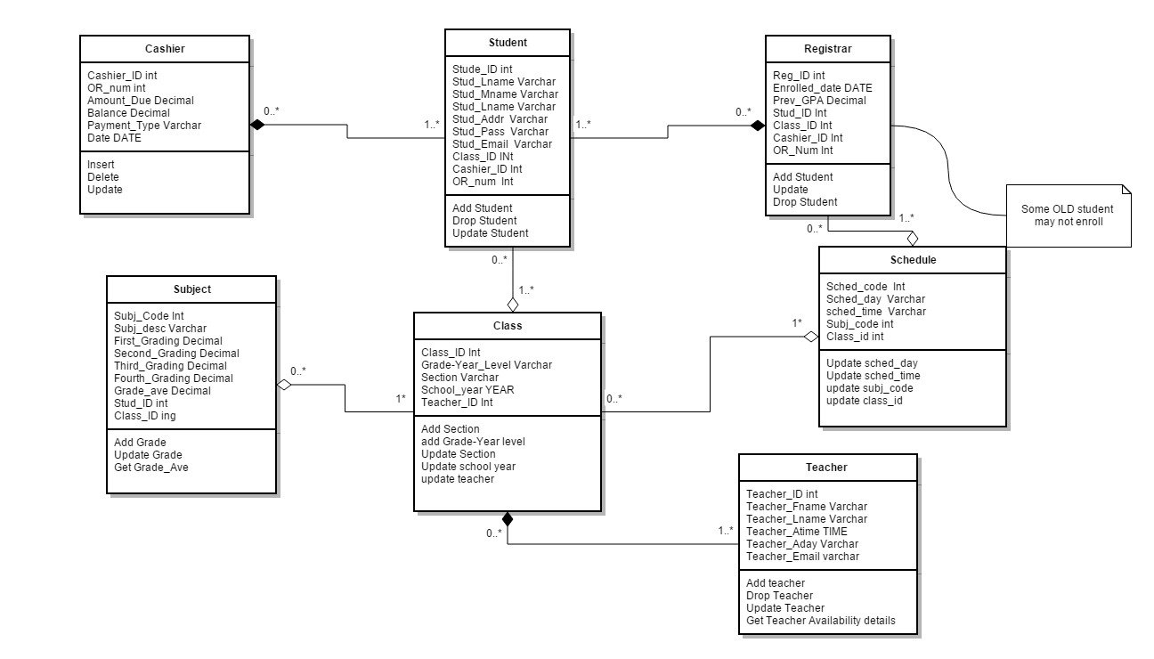

### [Component Diagram](http://creately.com/blog/diagrams/uml-diagram-types-examples/#ComponentDiagram)

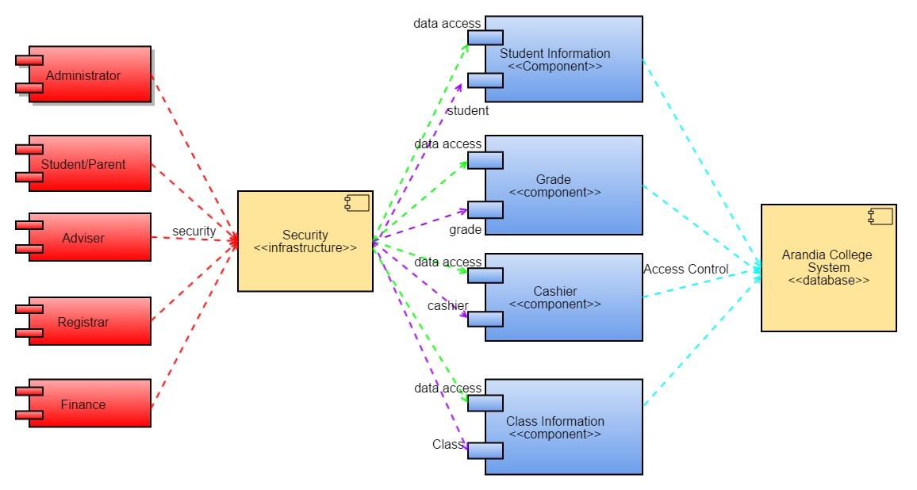

### [Deployment Diagram](http://creately.com/blog/diagrams/uml-diagram-types-examples/#DeploymentDiagram)

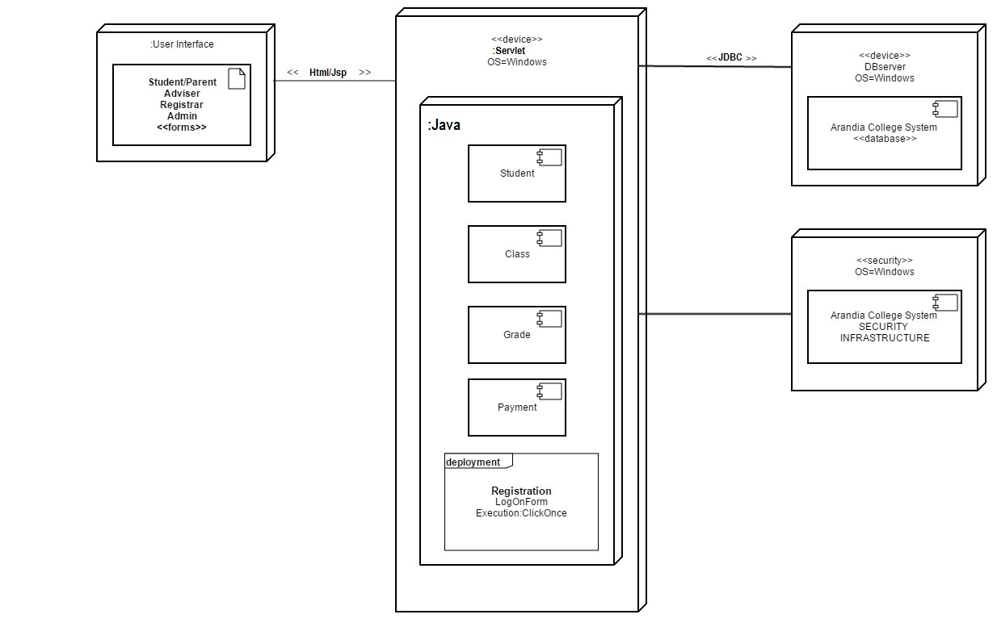

### [Object Diagram](http://creately.com/blog/diagrams/uml-diagram-types-examples/#ObjectDiagram)

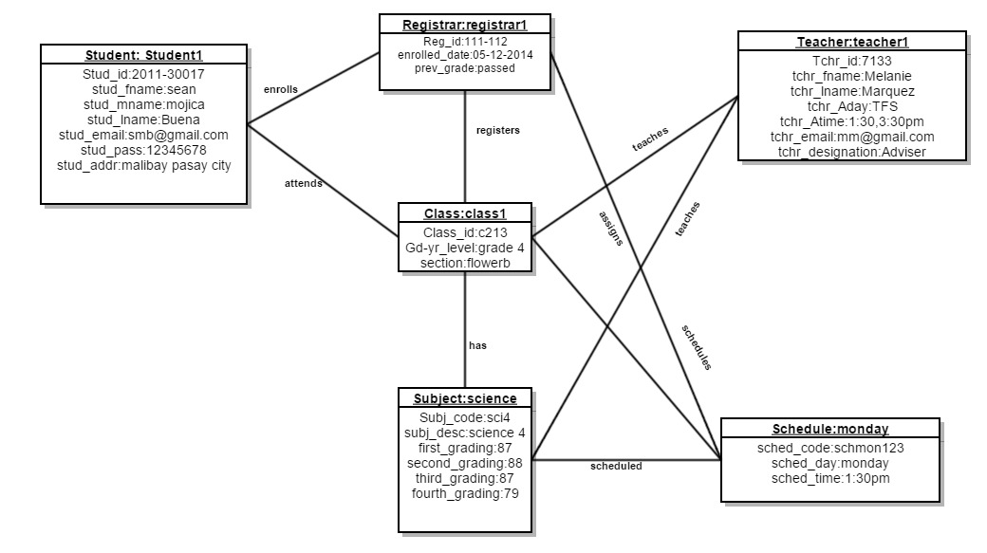

### [Package Diagram](http://creately.com/blog/diagrams/uml-diagram-types-examples/#PackageDiagram)

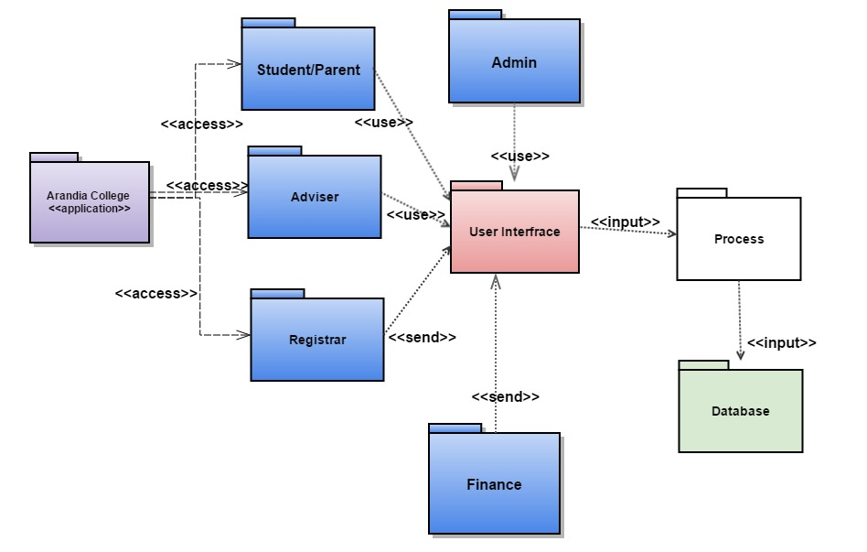

### [Composite Structure Diagram](http://creately.com/blog/diagrams/uml-diagram-types-examples/#CompStrDiagram)

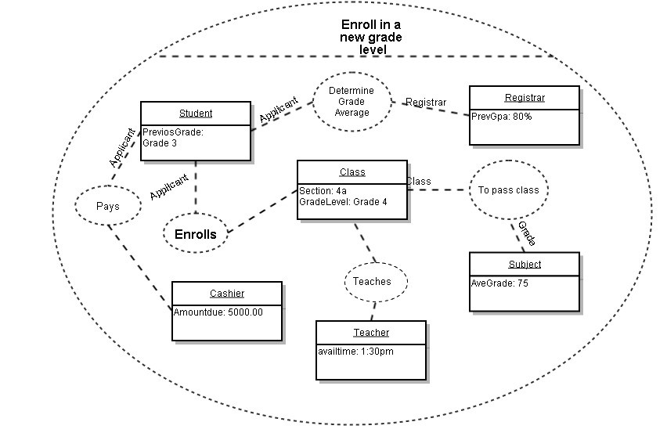

### [Use Case Diagram](http://creately.com/blog/diagrams/uml-diagram-types-examples/#UseCaseDiagram)

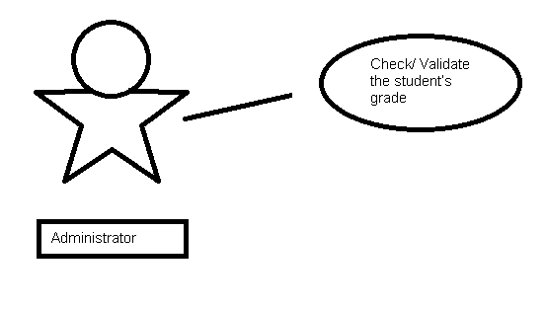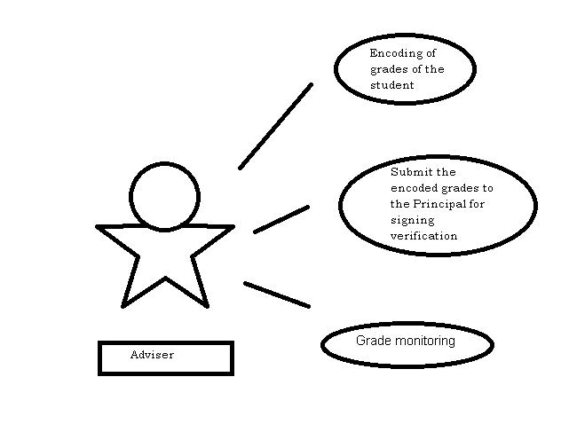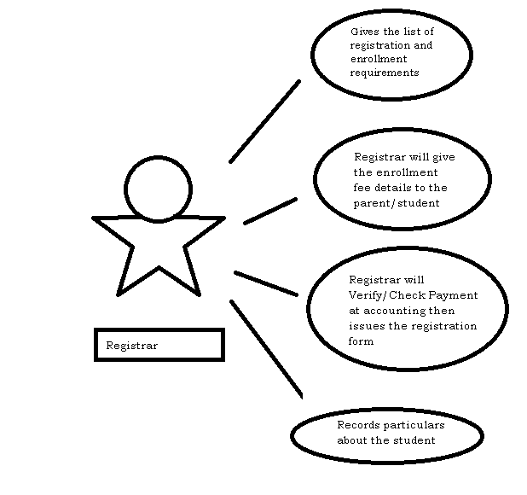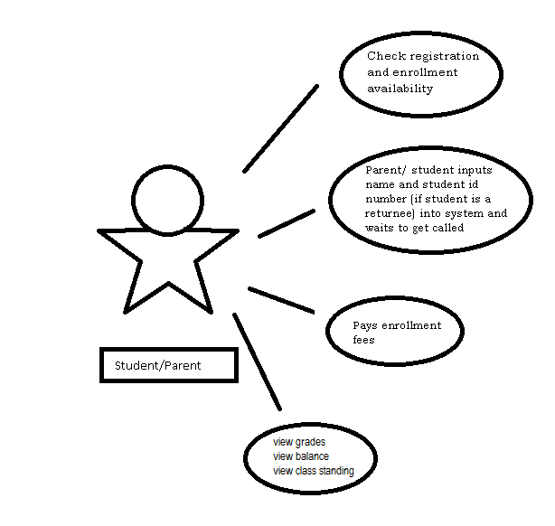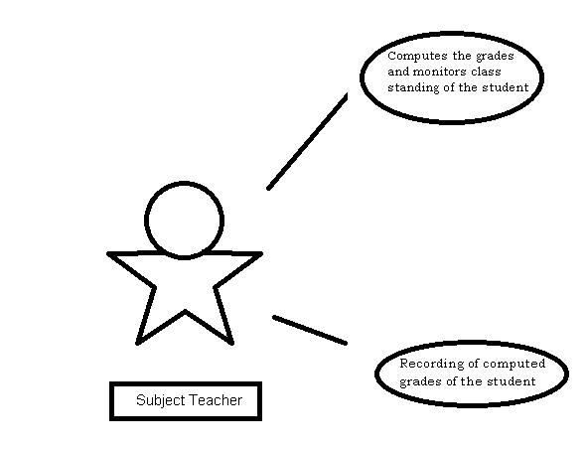

### [Activity Diagram](http://creately.com/blog/diagrams/uml-diagram-types-examples/#ActivityDiagram)

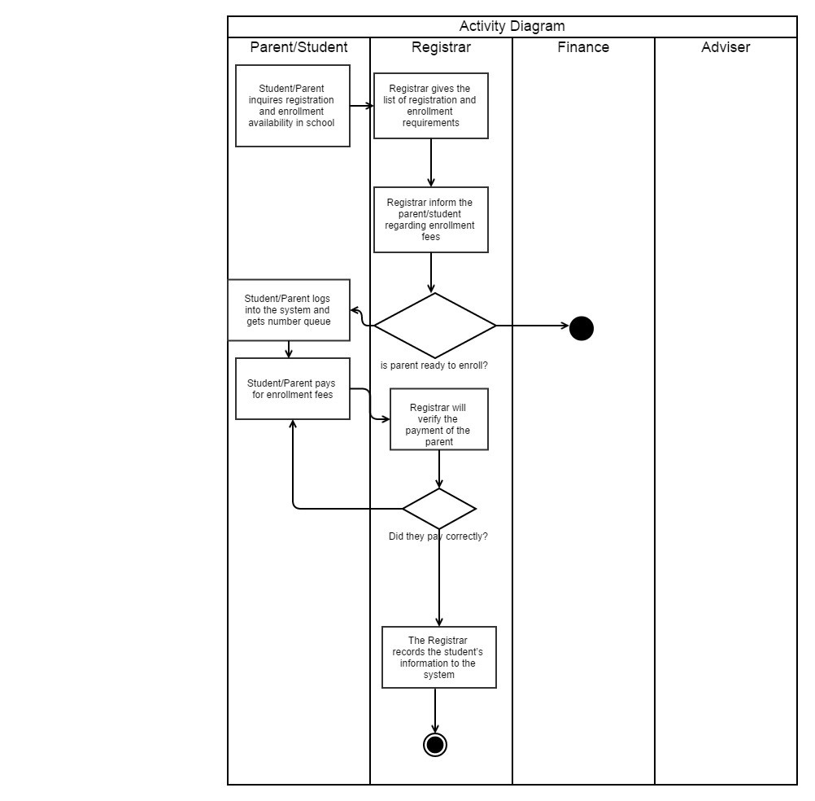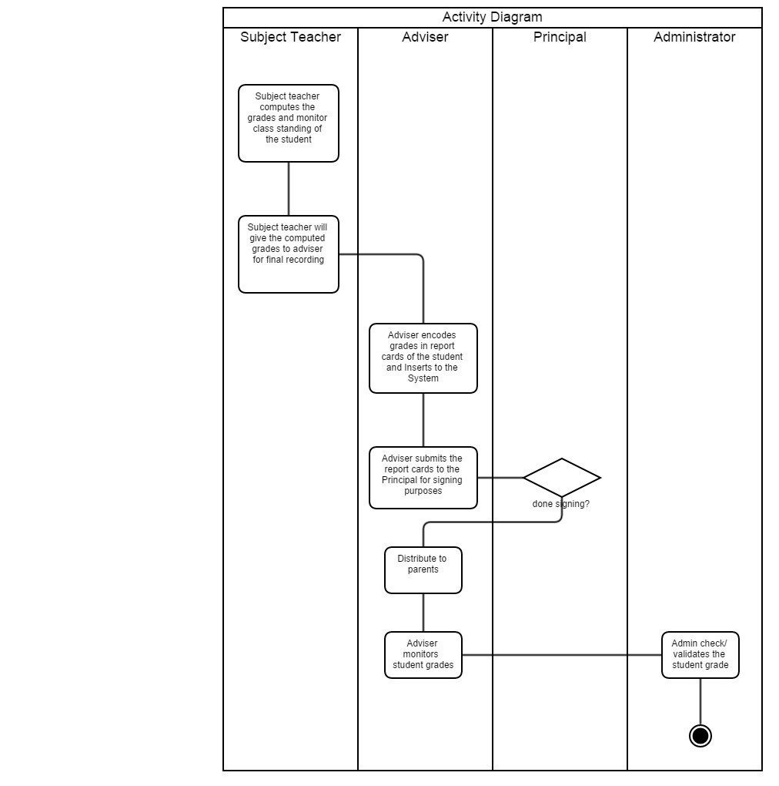

### [State Machine Diagram](http://creately.com/blog/diagrams/uml-diagram-types-examples/#StateMachDiagram)

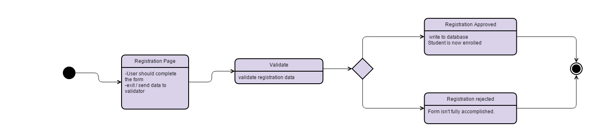

### [Sequence Diagram](http://creately.com/blog/diagrams/uml-diagram-types-examples/#SequenceDiagram)

### [Communication Diagram](http://creately.com/blog/diagrams/uml-diagram-types-examples/#CommDiagram)

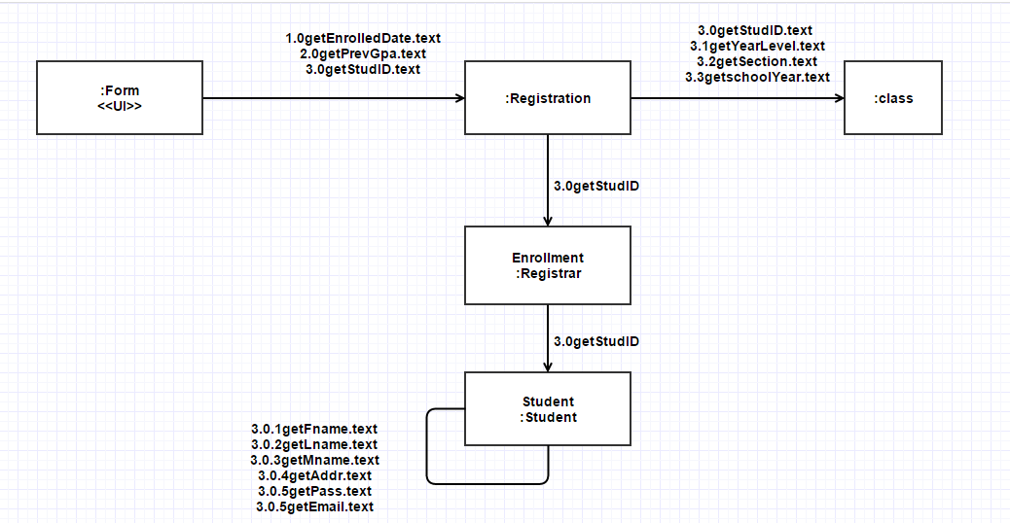

### [Interaction Overview Diagram](http://creately.com/blog/diagrams/uml-diagram-types-examples/#IntOverDiagram)

### [Timing Diagram](http://creately.com/blog/diagrams/uml-diagram-types-examples/#TimingDiagram)

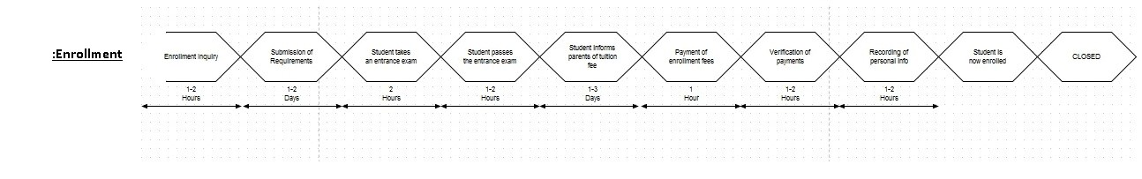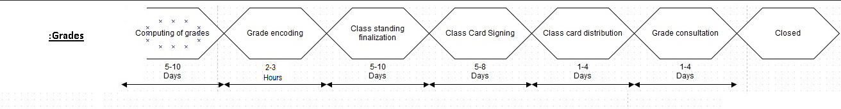

## Entity Relationship Diagram

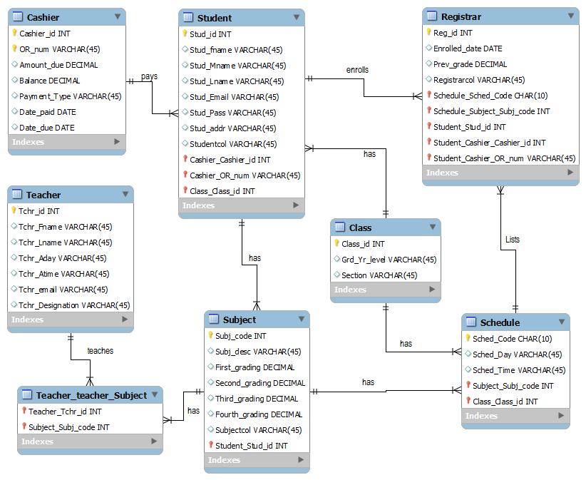

## Data Dictionary

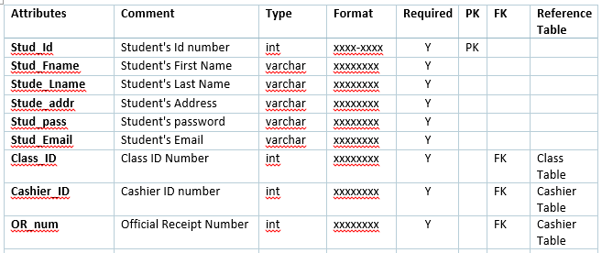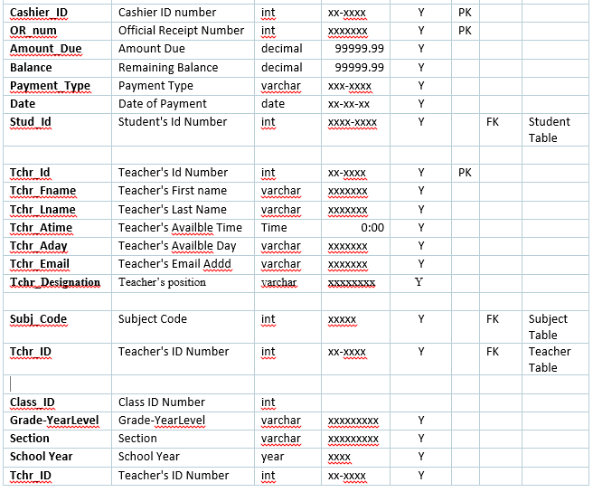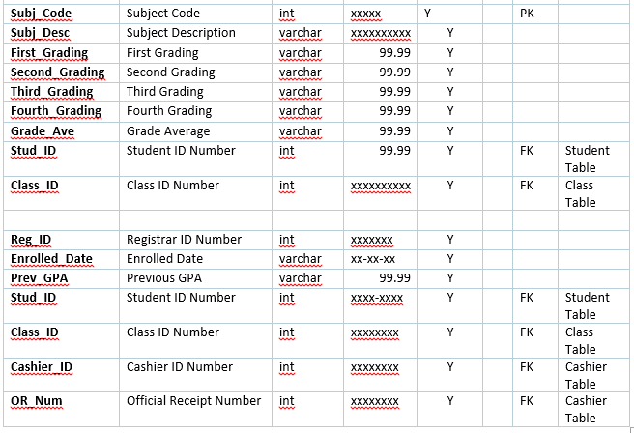

## Screen Shots

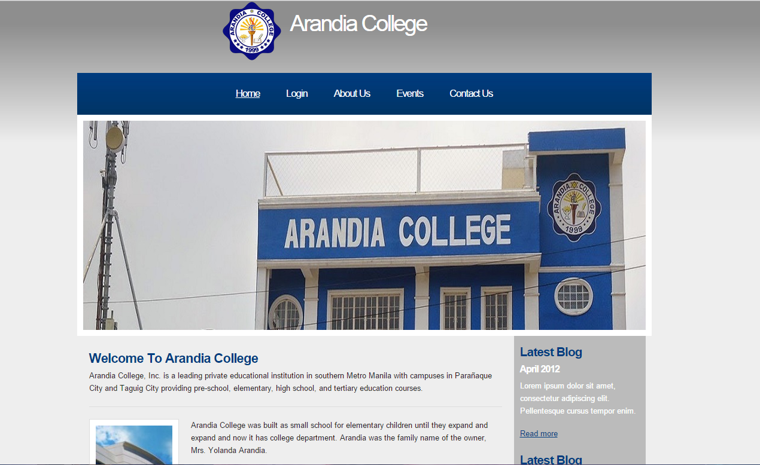

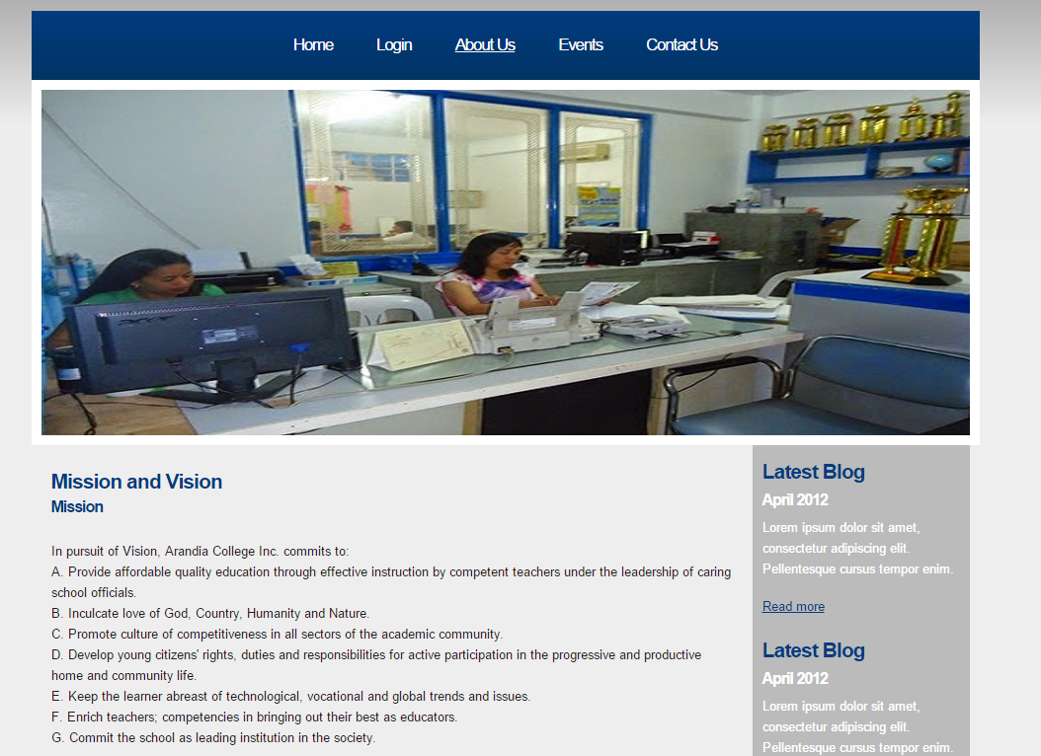

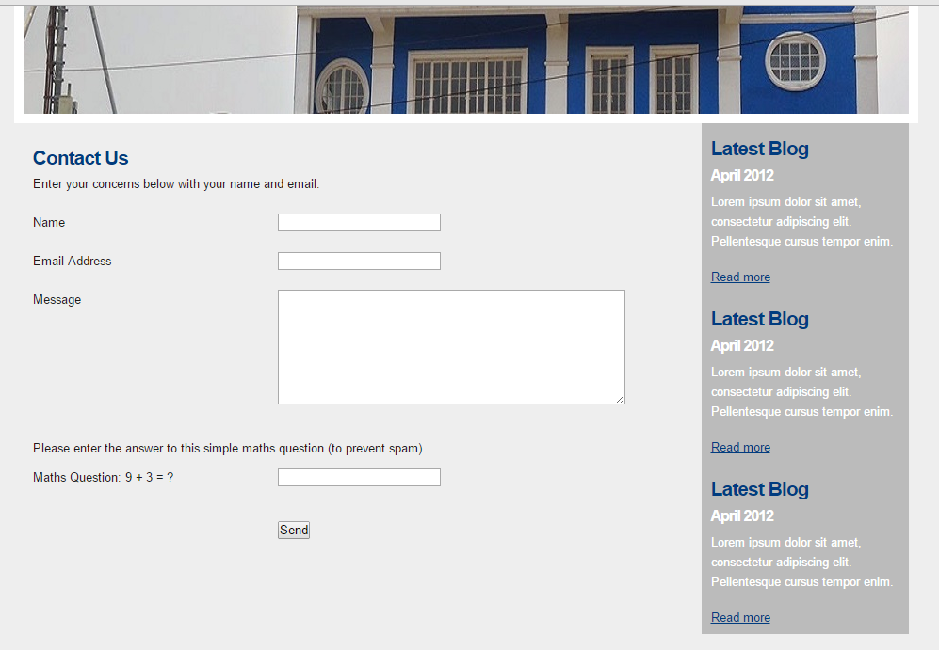

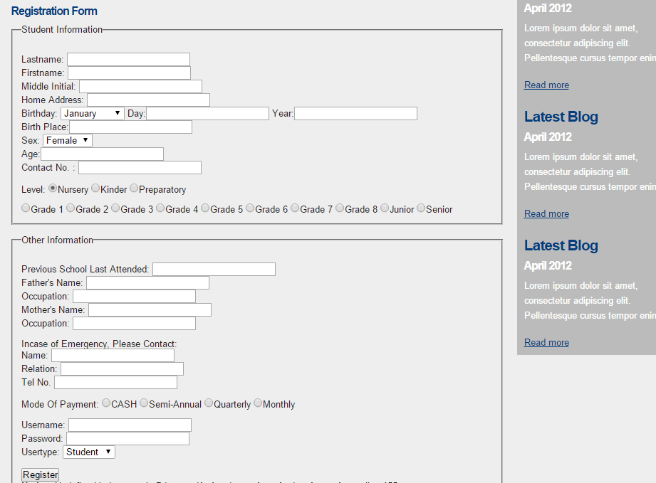

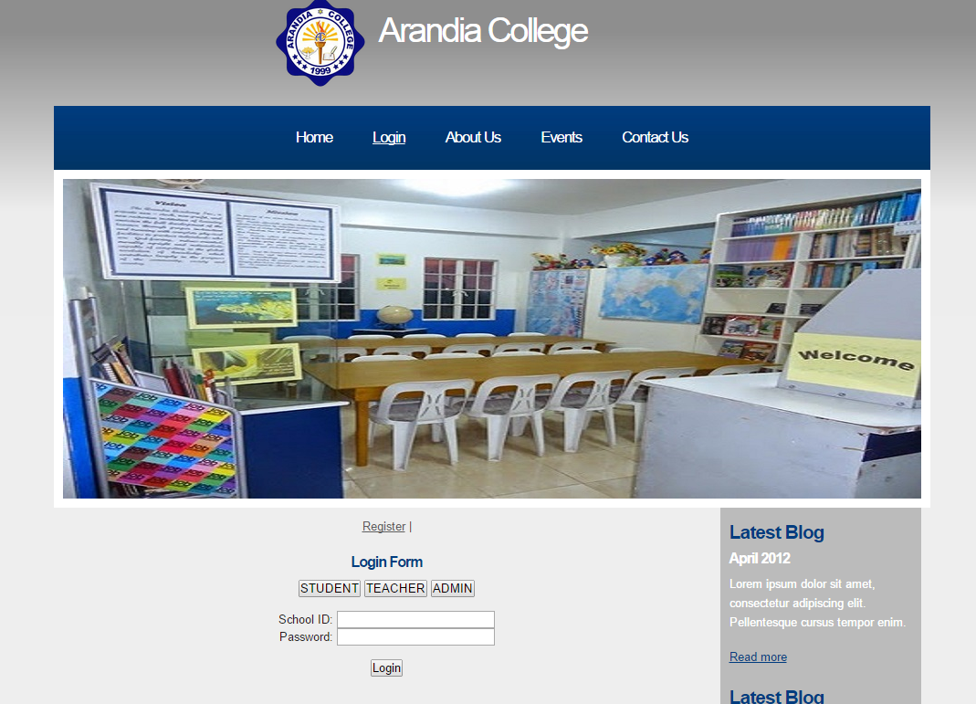

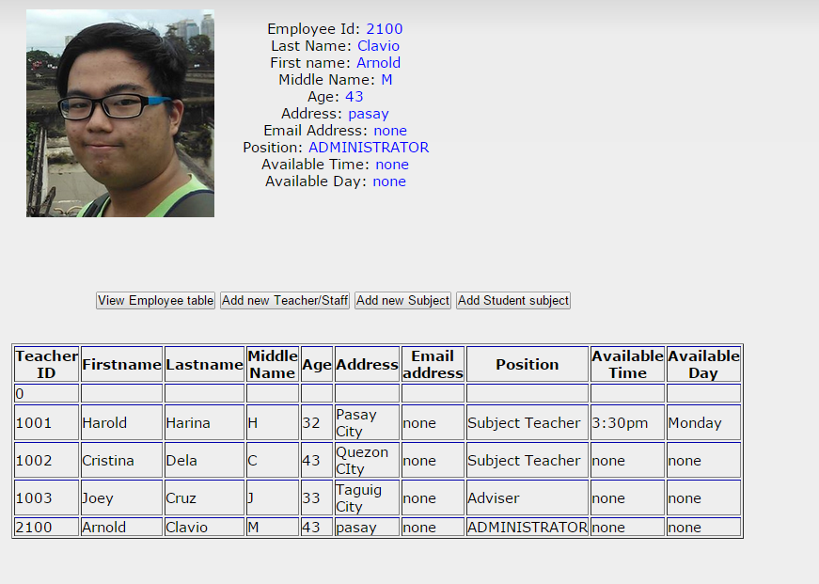

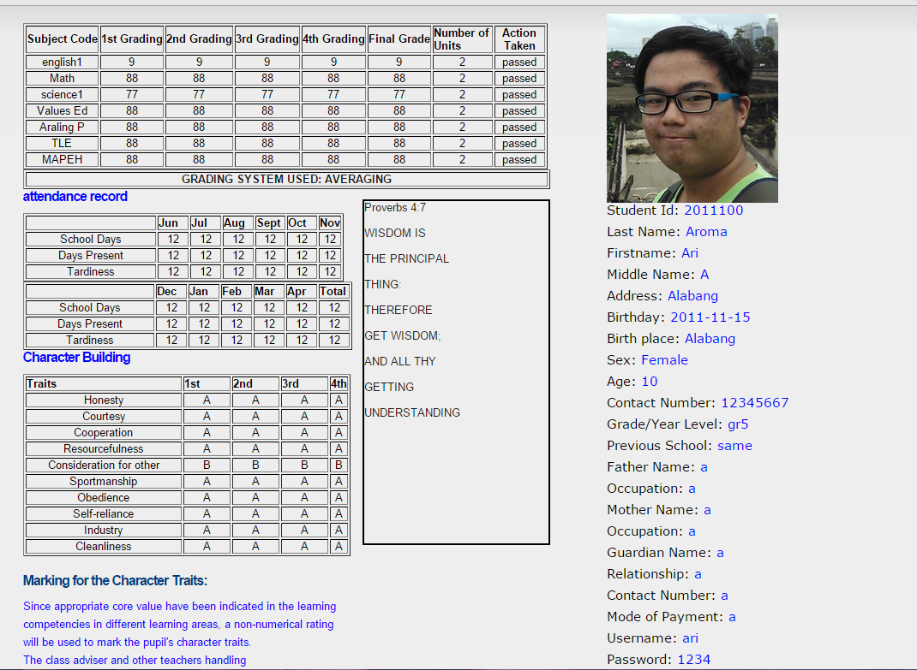

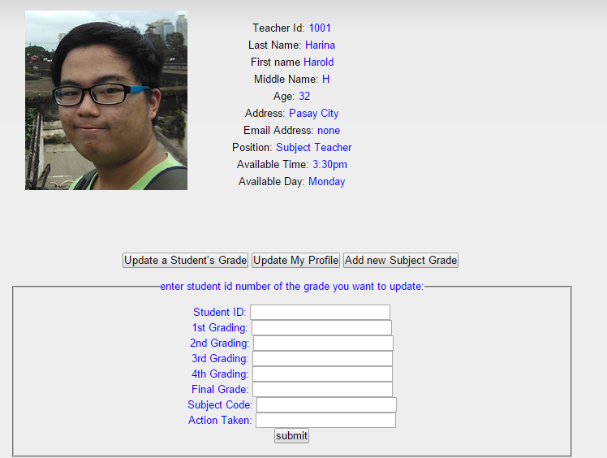

## Lesson Learned

IAN JASPER GUSI

* While making this project for consecutive terms, it goes without saying that this was obviously one of the most difficult tasks to complete. I have learned many things not just in making the project, but also in cooperating and communicating well with my fellow members. I learned that not only does gathering Intel from clients are hard, it was also quite a huge milestone for us to keep up with. And that developing a system wasn’t quite easy as I thought it would be, and it made me realize that there are a lot more that needs to be done before finalizing with this kind of project

SHEANNEL BUENAVENTURA

* During the development of the project, I have learned many things. It’s not easy to develop a system, you have to gather some information and frequently meet the client to get an idea on how you will design it. I have learned that there’s so many thing to go through just to release a running system for just one client, there’s so many paper works to accomplish and some other things to consider.

ANDRE POV FELIX

* Arandia college system is the Website of Arandia College. This log in log out, in this website you can see the subjects you enrolled, balance for tuition fees your tuition fee and you can see all of the teachers. For the staff is also log in log out, for example for teacher you can see their subjects that he or she holds and they can computes all pf the grades in this website. This website is simple but useful because you can only see the important matter for the all of the people in Arandia College.